Conclusions about the data

**Given the provided data, what are three conclusions we can draw about Kickstarter campaigns?**

From the three charts constructed in this exercise, we ca draw the following three conclusions:

1. The Theater category has the highest number of campaigns. There are nearly twice as many Theather campaigns (n=1,393) than campaigns in any other category. For example, Music is the second largest category with 700 campaigns.
2. There are more Kickerstarter campaigns to fund plays than campaigns to fund any other sub‑category type. The number of campaigns for plays (n=1,066) is over four times higher than the number of campaigns for any other sub-category type. For example, Rock music is the second largest subcategory with 260 campaigns.
3. The number of successful and failed campaign vary each month. Across the months of the year there are mostly more successful campaigns than failed campaigns, except in December when the number of failed campaigns is slightly higher.  
     
   Variation in the number of ‘canceled’ campaigns across the months of the year is smaller compared with variation in the number of successful and filed campaigns. Each month between 20 and 43 campaigns are cancelled.

**What are some limitations of this dataset?**

The data provided in the three charts describes the number of campaigns across categories, sub-categories and months of the year. They also provide a breakdown of the number of successful, failed, canceled and live campaigns in each category, sub-category and month of the year.

If we were looking to launch a Kickstarter campaign and we wanted to know when would be best to do so and which type of campaign would be more likely to be successful, we would find this data limiting.

We would need further analysis to give us data on the proportion of successful, failed, and canceled campaigns per category/subcategory and time of year.

These charts provide a breakdown of the count of campaigns rather than the proportion of campaigns by outcomes (ie successful, failed, canceled and live) for each category, sub-category and month of the year.

Another limitation is that it does not include data on the percentage funded for different campaign types. So, it does not tell us how successful or unsuccessful different campaigns can be. Some campaigns manage to attract much larger amounts of money than their goals, which means some successful campaigns can be much more successful than others. Without this data we cannot know which type of campaigns are likely to be more successful.

The three charts do not contain data on the number of backers and average size of donations that different campaigns attract. Without this data we cannot know how to best market our campaign, for example whether we need to appeal to a large number of donors or, instead, target a small number of very generous donors.

**What are some other possible tables and/or graphs that we could create?**

There are many other possible tables and graphs that we could create from the data set. Some examples are below.

Proportion of campaigns by category

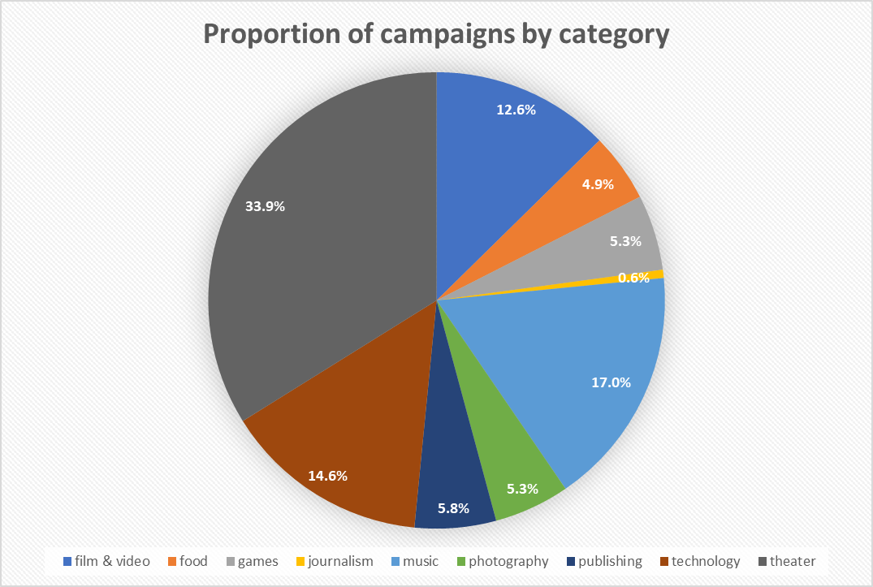

Proportion of successful, failed, canceled and live campaigns by month

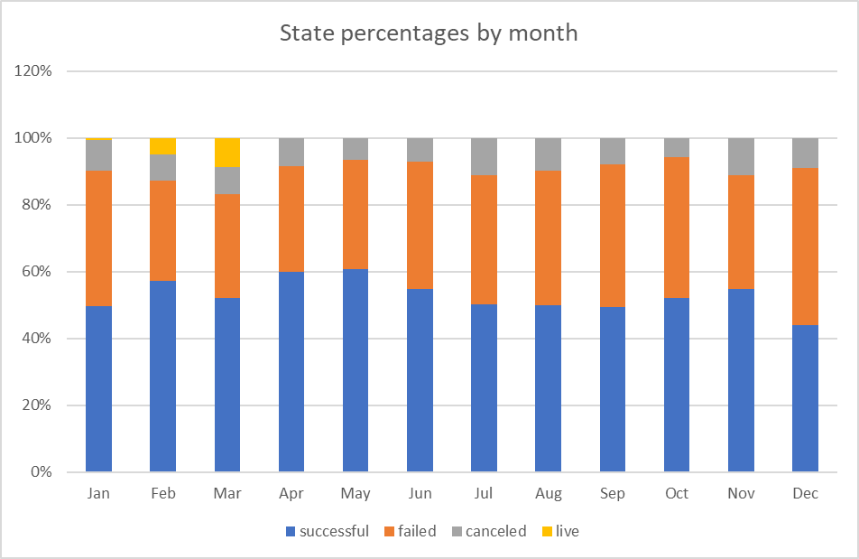

Proportion of successful, failed, canceled and live campaigns by category and sub-category

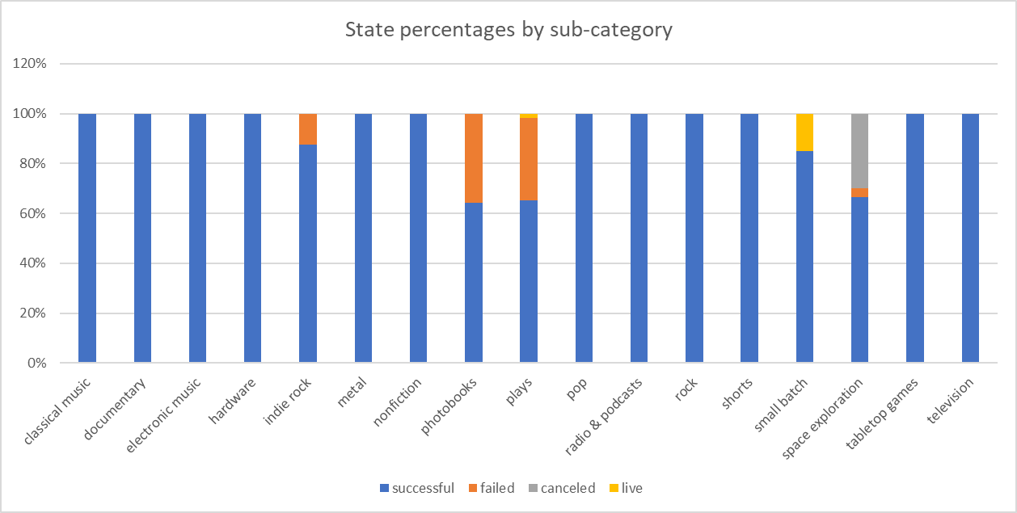

Proportion of successful, failed, and canceled campaigns by month of the year

